Ex. No. 1 | Java If Else
Date of Exercise

Aim
To demonstrate the implementation of conditional logic using `if-else` and `if-else if-else` statements in Java for varied program execution paths.
Description
/*
* The `if` statement is a fundamental control flow construct in Java. It evaluates a boolean expression.
* If the expression evaluates to `true`, the code block immediately following the `if` statement is executed.
*
* Syntax:
* if (condition) {
* // Code to execute if 'condition' is true
* }
*
* The `else` statement provides an alternative execution path. It is used in conjunction with an `if` statement
* and its block of code is executed only if the `if` condition (or the preceding `else if` conditions) evaluates to `false`.
*
* Syntax:
* if (condition) {
* // Code if true
* } else {
* // Code if false
* }
*
* The `else if` statement allows for checking multiple conditions sequentially. If the preceding `if` condition
* is false, the `else if` condition is evaluated. If true, its code block is executed. An `if` statement can
* be followed by multiple `else if` blocks, optionally ending with a final `else` block.
*
* Syntax:
* if (condition1) {
* // Code if condition1 is true
* } else if (condition2) {
* // Code if condition1 is false AND condition2 is true
* } else {
* // Code if all preceding conditions are false
* }
*
* Boolean expressions are crucial for these statements, resolving to either `true` or `false`. They commonly
* involve relational operators (e.g., `==`, `!=`, `<`, `>`, `<=`, `>=`) and logical operators (e.g., `&&`, `||`, `!`).
*/
Program
import java.util.Scanner;
public class IfElseExample {
public static void main(String[] args) {
Scanner scanner = new Scanner(System.in);
System.out.print("Enter an integer: ");
int number = scanner.nextInt();
// --- Example 1: Basic if-else statement ---
System.out.println("\n--- Basic if-else ---");
if (number > 0) {
System.out.println("The number " + number + " is positive.");
} else {
System.out.println("The number " + number + " is non-positive.");
}
// --- Example 2: if-else if-else ladder ---
System.out.println("\n--- if-else if-else ladder ---");
if (number > 0) {
System.out.println("The number " + number + " is positive.");
} else if (number < 0) {
System.out.println("The number " + number + " is negative.");
} else {
System.out.println("The number " + number + " is zero.");
}
scanner.close();
}
}
Output
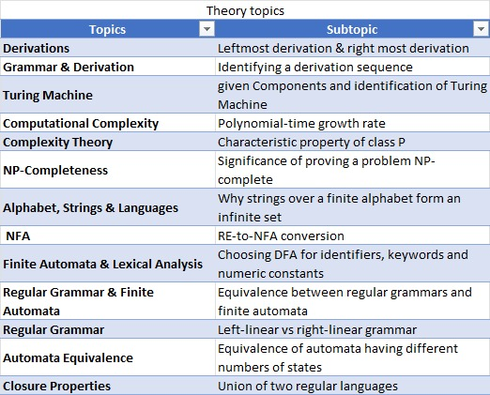
Result
--- Sample Execution 1: Input 10 --- Enter an integer: 10 --- Basic if-else --- The number 10 is positive. --- if-else if-else ladder --- The number 10 is positive. --- Sample Execution 2: Input -5 --- Enter an integer: -5 --- Basic if-else --- The number -5 is non-positive. --- if-else if-else ladder --- The number -5 is negative. --- Sample Execution 3: Input 0 --- Enter an integer: 0 --- Basic if-else --- The number 0 is non-positive. --- if-else if-else ladder --- The number 0 is zero.

[Kindly Note: Exercise Number and Title of Exercise should be changed in the footer as per the respective exercise]

